 Epimap v2

Documentation

*Intr*

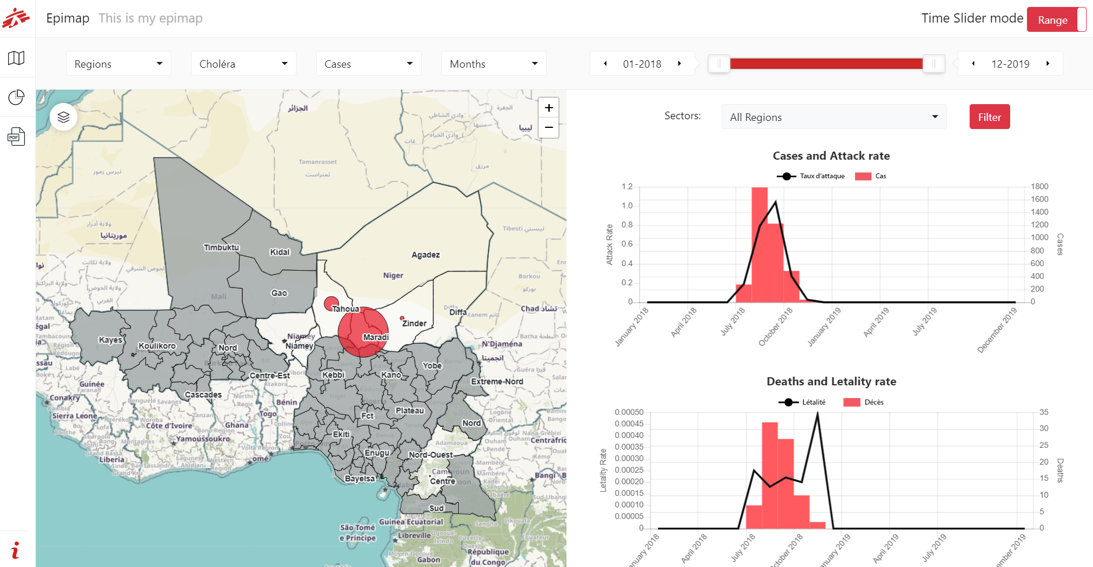

Contents

1. Tool general presentation 3

2. Epimap interface 4

2.1. Global Interface 4

2.2. BaseMap and Label Control 5

2.3. Spatial Scale 5

2.4. Disease selector 5

2.1. Time Slider 5

2.2. Indicators 6

2.2.1. Indicators definitions 6

2.2.2. Visualizations on the Map 6

2.2.1. Visualizations in the Charts 7

2.2.1. Visualizations in Table 8

2.3. InfoBox 8

3. Intermediate Use - Updating data in an existing Epimap 9

3.1. Updating epidemiological data 9

3.1.1. Formatting epidemiological data 9

3.2. Updating spatial data 10

3.3. Updating the configuration file 10

3.3.1. Name of the Epimap 10

3.3.2. Time Units 11

3.3.3. Geographical levels 11

3.3.4. Disease 12

4. Advanced Use – Setup and customization of an Epimap 15

# Tool general presentation

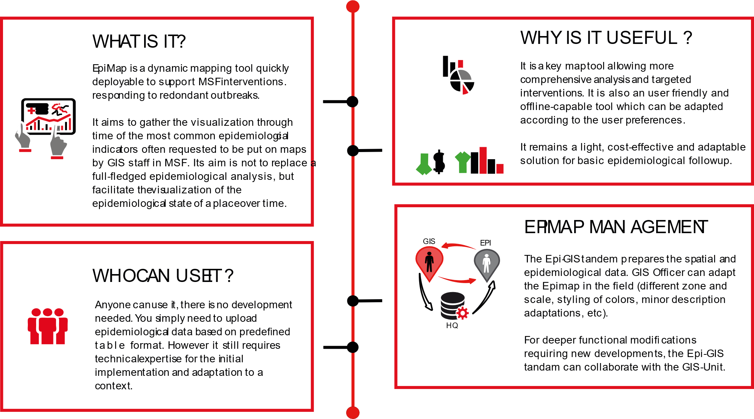

# Epimap interface

*This part is destined to standard users who only consult the Epimap. For users who need to update the data in the Epimap, refer to part 2. For initial setup and advanced customization of the tool, refer to part 3.*

## Global Interface

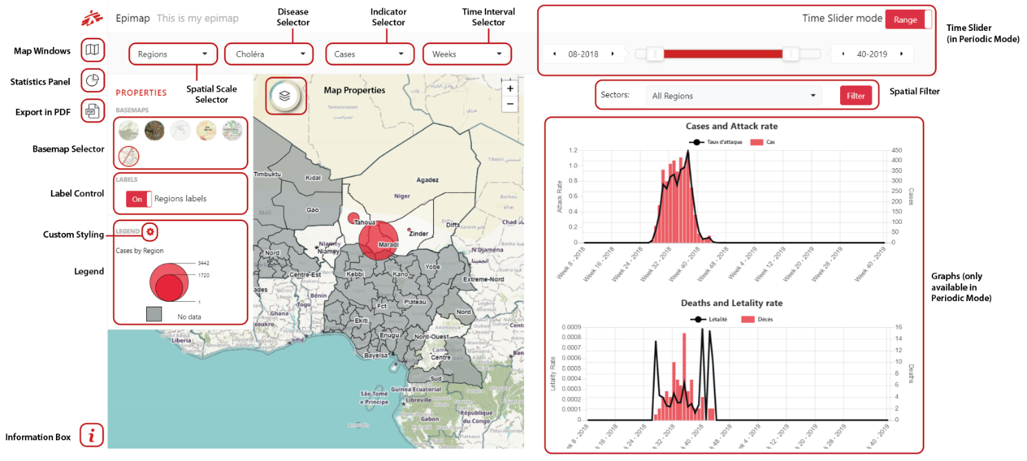

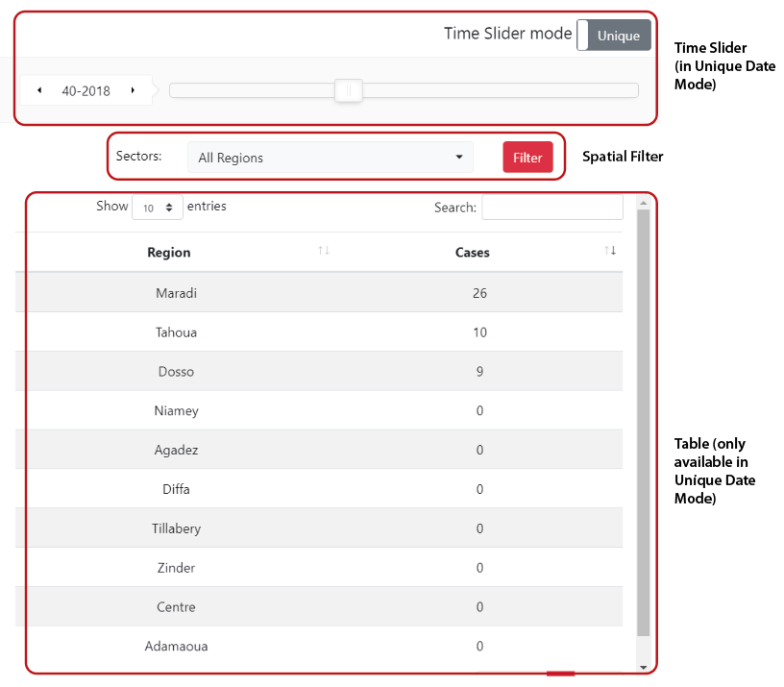

## BaseMap and Label Control

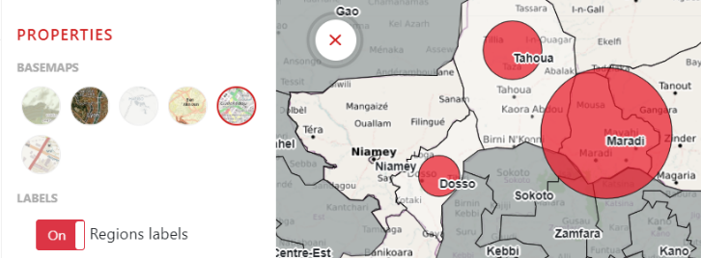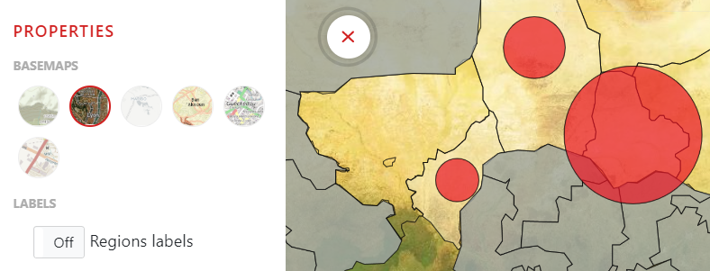

The BaseMap allows to choose between available map backgrounds, while the Label switches names of the polygons on/off on the map. Note that Basemaps are fetched from internet, therefore, they are the only feature of the Epimap relying on an internet connection.

## Spatial Scale

The EpiMap v2 is able to work at several spatial levels (in this example, Regions and Districts). Please note all Epidemiologic is entered at the smallest available level. Data for upper spatial levels are directly generated by the app by aggregation, and it currently not possible for them to have specific / different calculations.

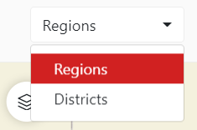 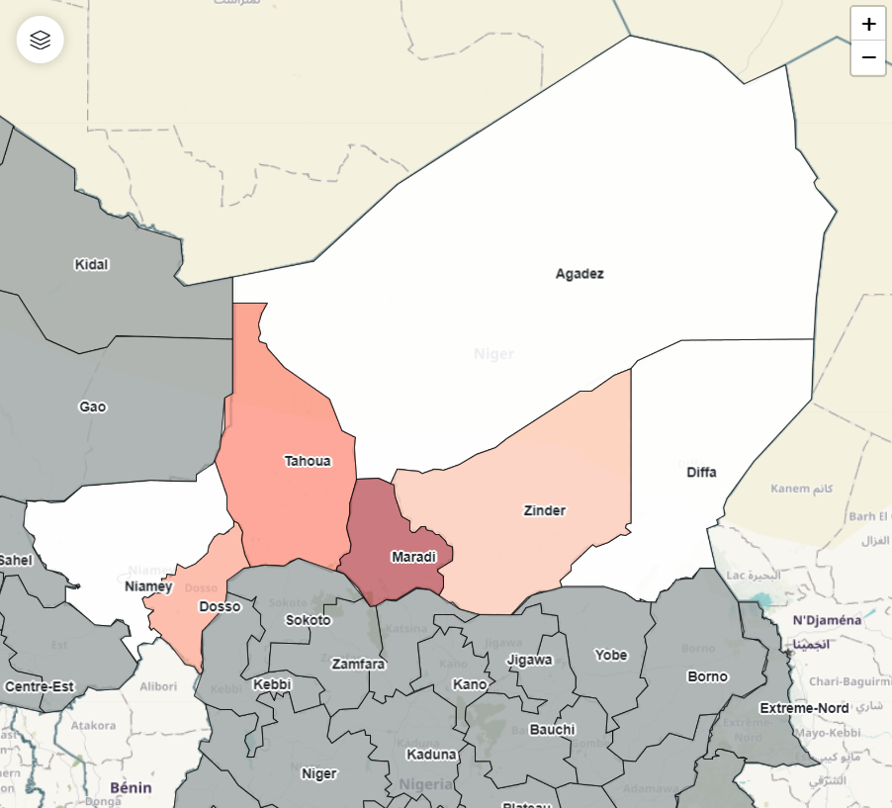 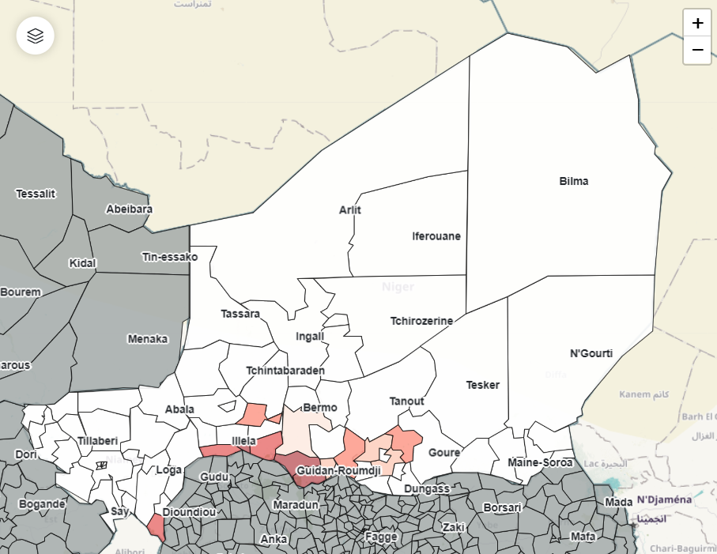

## Disease selector

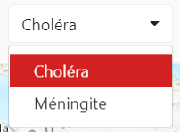 The Epimap is able to display data for numerous diseases (2 are provided as examples, Cholera and Meningitis). The user is not choosing from an existing set of disease, but is able to define manually the name of a disease – using for instance the name of the disease in another language. There is no limit to the number of diseases you can input to the application, but going beyond 4-5 of them will multiply the size and weight of your entry dataset. This can affect the performance, speed and stability of the application.

## Time Slider

The Time Slider is the most important filter of the Epimap after the Disease selector. It has two available modes named Range and Unique. The **Range Mode** provides a periodic view from date A to date B, both defined separately :

 

The **Unique mode** provides a Snapshot of a time unit (based of the interval chosen, this time unit can be a Day, Week, Month or Year):

 

## Indicators

### Indicators definitions

The Epimap proposes 4 indicators: **Number of Cases**, **Attack Rate**, **Number of Deaths**, and **Lethality**.

**Number of Cases** and **Number of Deaths** are simple integer variables.

**Attack Rate** is calculated by dividing number of new cases of disease during the specified time interval, with the population.

* To grant maximum flexibility to the user[1], attack rate is inputted in the data by the users at the smallest spatial scale and the smallest time interval possible. The Epimap aggregates attack rate through time and spatial scale.
* The Application does not have the population as part of the data input. The attack rate is precalculated outside the application, and population is therefore implicit. It is not possible to take into account variations of population through the outbreak.

**Lethality** is calculated by dividing, for one disease, one zone and given period of time, number of cases by number of deaths.

* Lethality is calculated directly by the application (based on cases and deaths numbers) and aggregated through time and spatial scale.

### Visualizations on the Map

Numbers of Cases and Number of Deaths visualized as proportional circles on the Map.

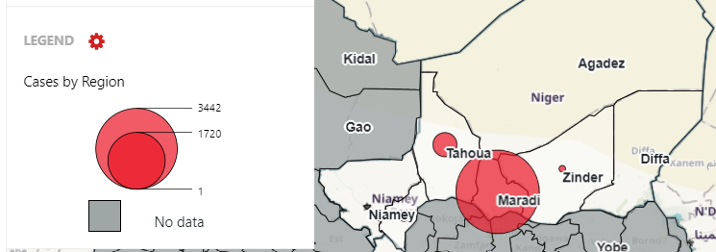 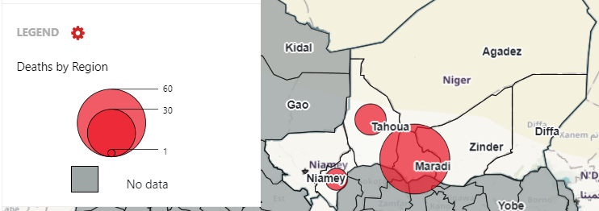

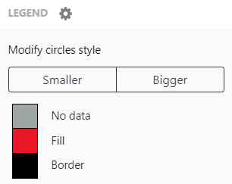

By using the Custom Styling button in the Legend Panel, you can adjust colors to better emphatize your data :

* 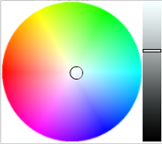the base size of the Proportional Circles
* the color of Fill and border of the figures
* the No_Data color value

Attack Rate and Lethality are symbolized by colors shades on the Map.

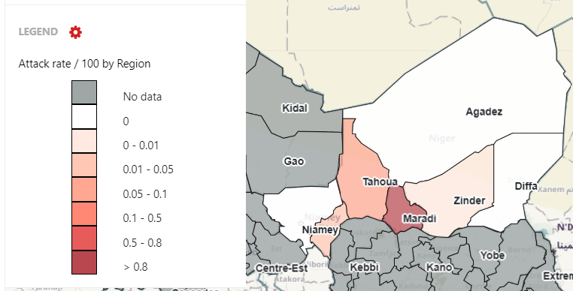 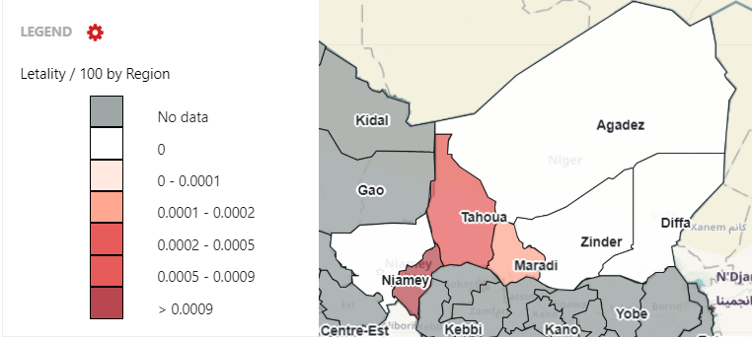

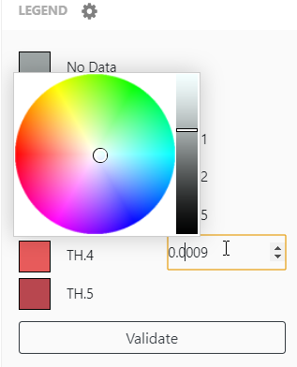

By using the Custom Styling button in the Legend Panel, you can adjust colors to better empathize your data, as well as the values of the Tresholds between classes. You can also adjust the No_Data color values.

*Reminder: Base users are able to adjust these values on-th-fly during a browsing session only (settings will not be saved at the end of the session when closing the Epimap). The Epimap manager can modify the default value of these parameters in the configuration file.*

### Visualizations in the Charts

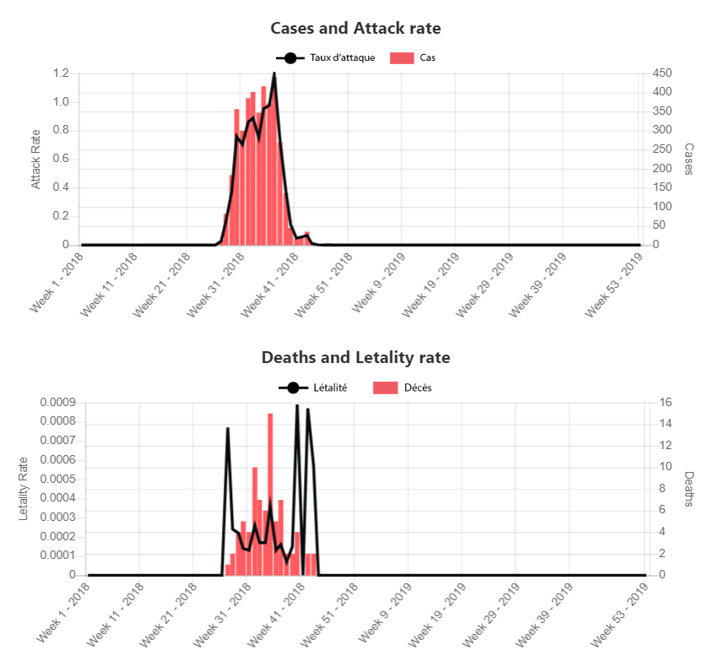All indicators that are visible on the map for a given disease, are also displayed on bar charts on the right panel of the App.

These charts are affected by the spatial filter and the Time Slider (time interval unit, and selected time period).

Charts do not have customization options nor specific export functions (use a normal screenshot to export images of a graph).

Graph are only available when the Time Slider is on Periodic (range) mode.

### Visualizations in Table

The Table visualization is only available when the Time Slider is set to “Unique Date” (not Periodic). The table will display the areas names (at chosen spatial level) and the indicator selected in the Indicator Selector.

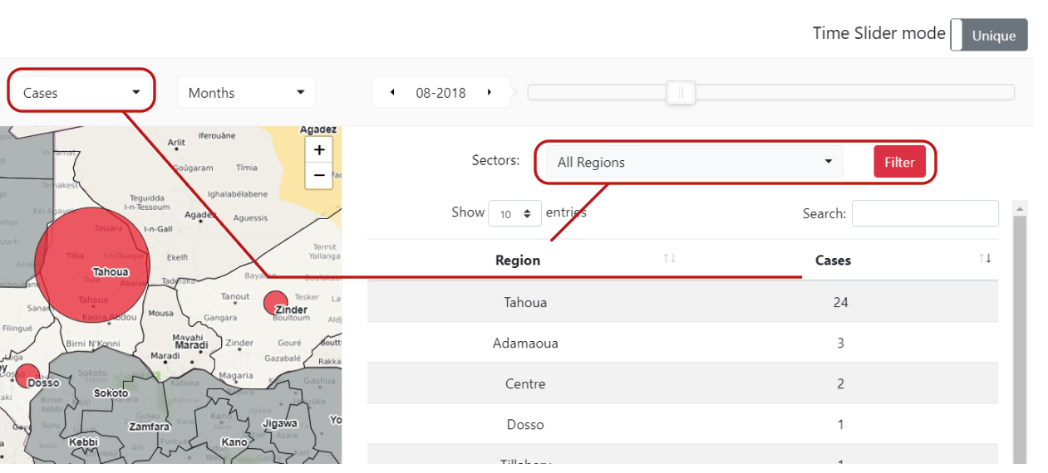

## InfoBox

Clicking on the “i” button at the bottom left of the screen, will trigger the opening an Info Box is a section of the Epimap containing explicative text, comments, or source information related to the Epimap.

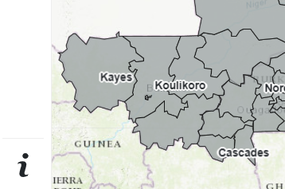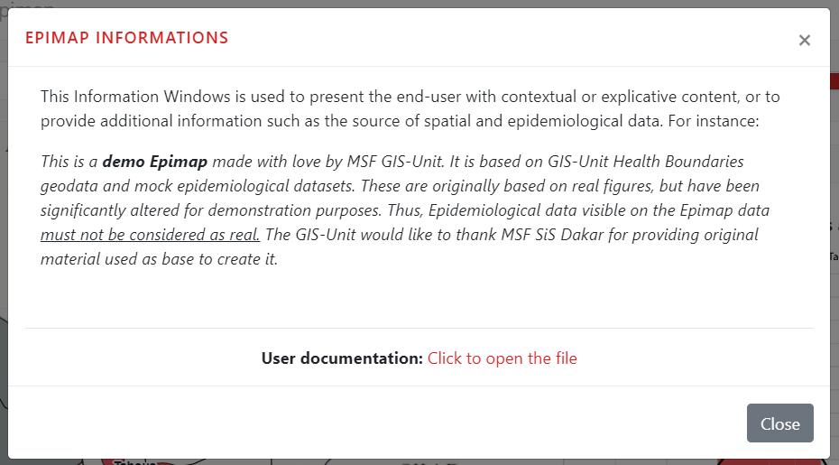

The Infobox also contains a link to this User Documentation. It is not possible to insert comments directly in the Epimap itself apart from this window - however, if you have information you want to make sure that user will see at all times, you can customize this InfoBox so it always shows up by default when the Epimap opens (see 3.3.)

## PDF Export

# Intermediate Use - Updating data in an existing Epimap

## Updating epidemiological data

Epidemiological data is stored within the [DATA] folder of the Epimap under the name “**dataset.csv**”. The epidemiological dataset is using a very specific structure. This structure cannot be changed.

The data model is based on the smallest spatial polygons (in this case level 2) and the smallest time unit (in this case, days).

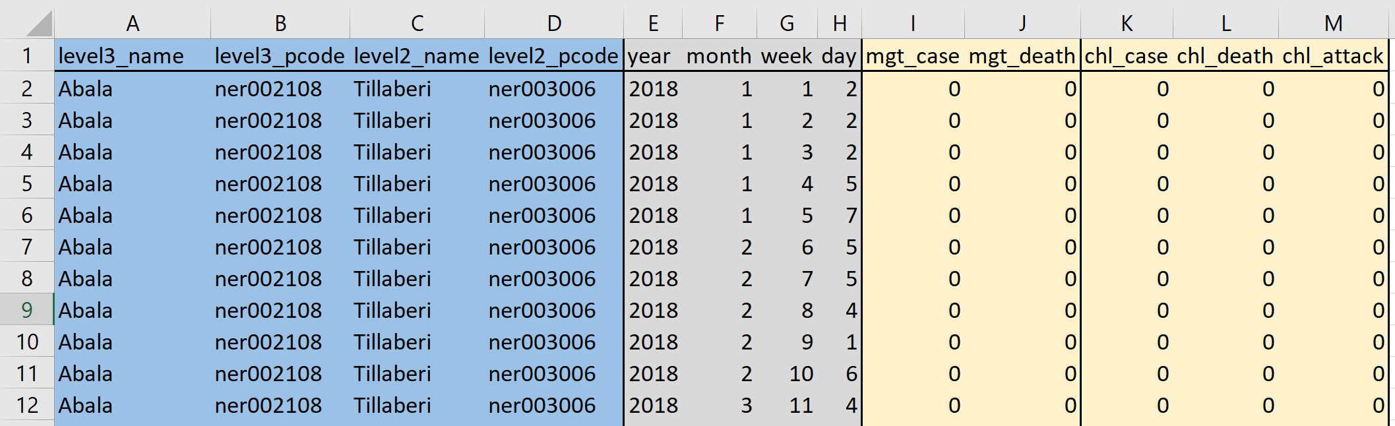

|  |  |  |
| --- | --- | --- |
| **Type** | **Description** | Note |
| Spatial reference columns | PCODE & Name for each desired spatial level (up to 3)  Level 1 = largest  Level 3 = smallest | * Generally based on Health Boundaries, but you can use political boundaries or camp boundaries instead |
| Temporal unit columns | Options possible:  Year, Months, Week, Day | * You can use 1, 2, 3 or 4 of these columns if relevant to your data (delete the unused columns) |
| Disease indicators  Example here on meningitis (mgt) and cholera (chl) | Possible indicators: Cases, Deaths, Attack Rate, Lethality | Lethality is calculated automatically by the app, and Population is not needed by the app itself (though you did need it to create the Attack Rates) |
|  |  |  |

There is no exact step by step and how-to about how to manipulate Excel to reformat your data from its original structure into the structure needed by the Epimap. You can base yourself on the example dataset within the Epimap (contains year/month/weeks/days combination for 2 years already), as well as the following tool in Excel.

* Using Pivot Tables to create a Cartesian Product (combine all combination possibilities from 2 lists): <https://chandoo.org/wp/generate-all-combinations-from-two-lists-excel/>
* Using the VLOOKUP formula in Excel: <https://exceljet.net/excel-functions/excel-vlookup-function>

### Formatting epidemiological data

* The decimal symbol (only useful for Attack Rate field), is a dot symbol “.”
* The Epimap works with the comma character “,” as a field separator. When exporting your data from Excel, use File Menu > SaveAs > CSV (Comma-Separated-Value) file .csv

*Doublecheck your dataset: depending of the regional & language settings of your computer, some versions of Excel may override this setting and automatically use other separators (Tab, semicolon “;” etc).* To be sure, the best way is to open your dataset in a plain text editor (NotePad, Notepad++, Atom, etc)

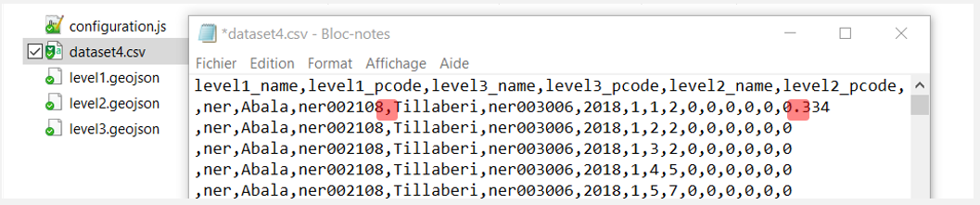

Figure 1 - Correct formatting: comma as field separator and dot for decimal values

## Updating spatial data

Base spatial data for Epimap v2 are polygons. They must contain a PCODE column coherent with the Epidemiological dataset. Geographical files must be in GeoJSON format and names of the polygon must use UTF-8 encoding to be displayed properly. You have to create a GeoJSON file for each geographical level you set in the configuration file.

The geographical files must be named as level+number.geojson. Exemple: level2.geojson

# Advanced Use : Updating the configuration file

The configuration.js file is located within the [DATA] folder of the Epimap. **This file is case-sensitive and you must modify it with caution**. Be sure that every “{“ and “[“ characters are closed by “}” and “]” characters and that you have a comma at the end of each parameters lines.

### Name of the Epimap

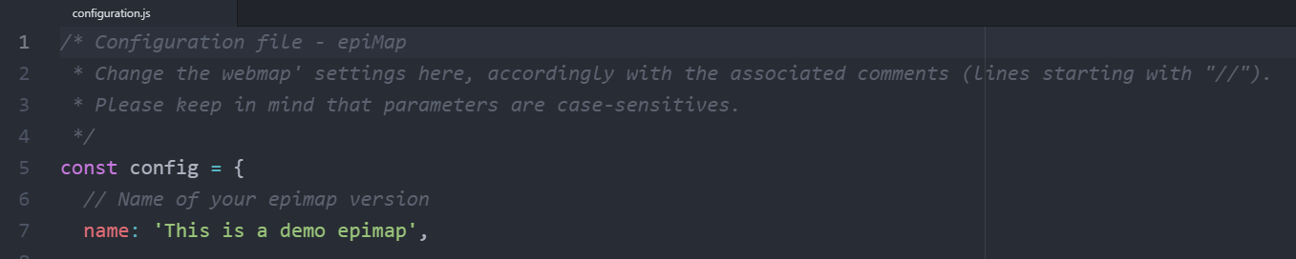

If you modify ‘this is a demo Epimap’ into another text, it will modify the title of the Epimap.

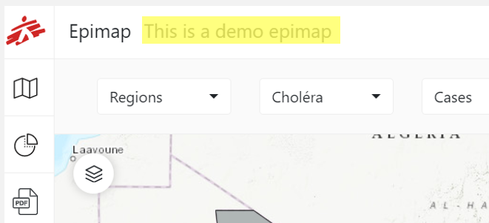

### Time Units

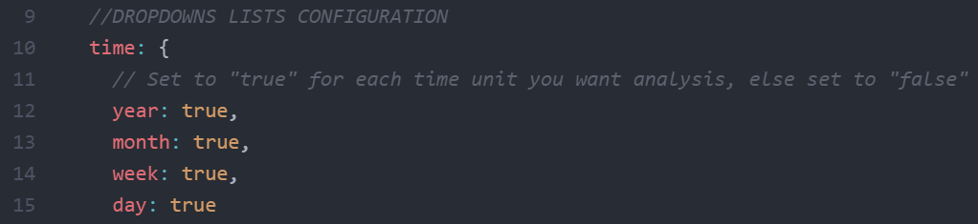

Modifying these values will affect the time units available in the Epimap. True will indicate that the App will try to display them, false implies that the App will ignore them.

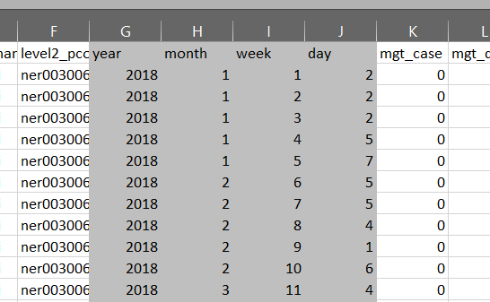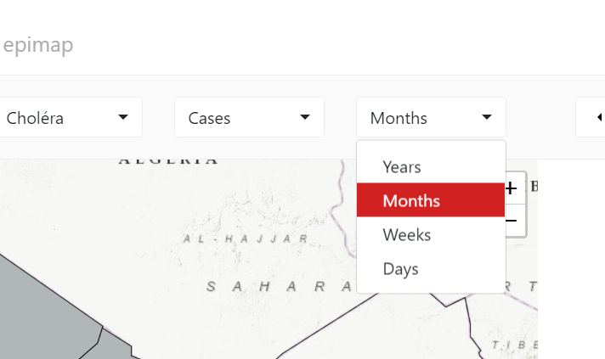

Advice: If you set a time unit to true, you must make sure you have included them in the data model, or the app will be unable to load & use them.

### Geographical levels

Next step is to indicate to the Epimap what are the Geography levels you are working with. You can work with 1, or 2, or 3 spatial levels. The Epimap cannot know if they are neighborhoods, camp zones, health areas, health zones, electoral boundaries, districts, countries …. so you have to specify it.

* Level 1 is always the “largest” special level (eg countries for example)
* Level 2,3 are smaller and smaller (Regions, then Districts, for instance)

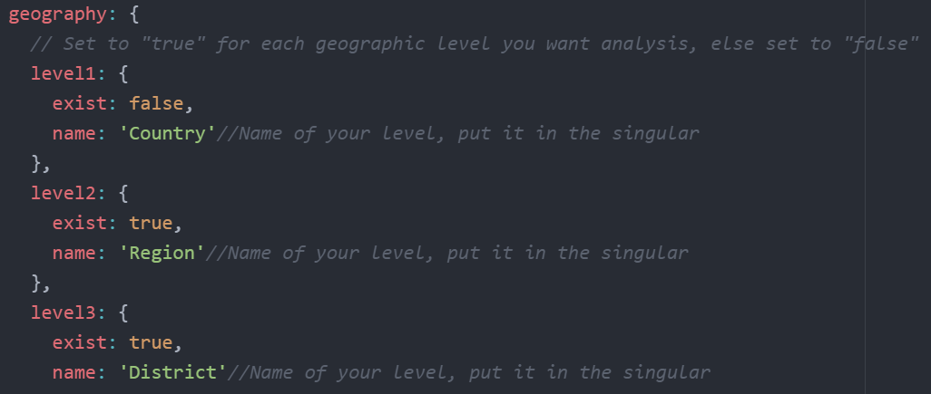

In the example above: I decide I want my Epimap to work with level 2 (Regions) and 3 (Districts).

In the configuration file, I set level 2 and 3 to true, level 1 to false. I inform the app that level 2 means “Region” and level 3 is “District”

1. I verify that in my Data Folder, I have at least level 2 and 3 as GeoJSON, as these levels have been set to true. *Remark:* *Note that in my [DATA] folder, I also have a level 1 geojson (countries). As this level has been set to false in the code, the app will not try to consult/display it, it will be ignored.*
2. I verify that in my Data Model, I have names and PCODES for level 2 and 3, corresponding with the Names and Pcodes present in the attribute table of the GeoJSON.
3. The app now works with Regions and Districts.

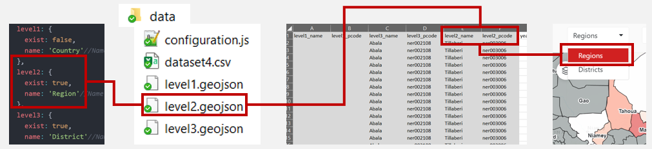

### Disease

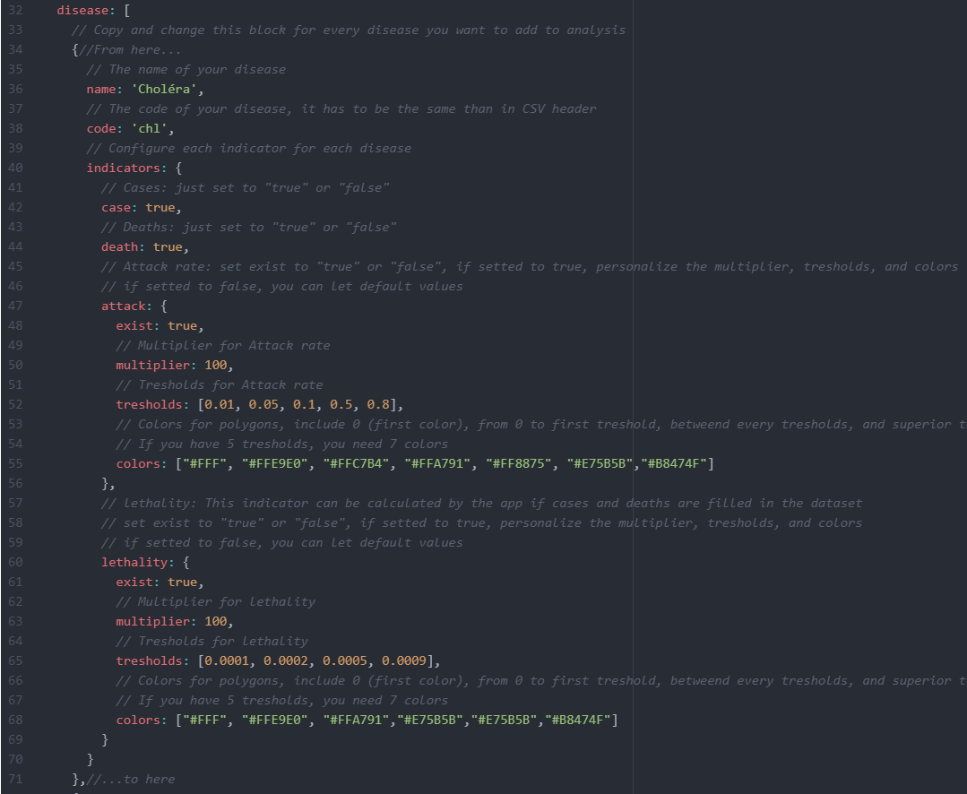

Each disease is described as a “bloc” in the configuration.js code, with several part describing it. We will take here the example of the Cholera disease.

* **Disease Name**

name: 'Cholera' The “explicit” name of the disease, as it will appear in the menus, the legend, etc

* **Disease Code**

code : ‘chl’ The 3-leter code of your disease, used in the Epidemiological dataset :

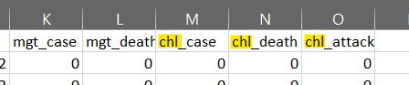

Note : to allow you to add any disease in the data model, you can use any 3-letter code you want (chl, ebl, mlr, vih, etc…). However, the suffixes _case, _death and _attack cannot be changed.

* **Indicators**

The 4 possible indicators are Cases, Deaths, Attack Rate, and Lethality. For each of them, the value exist:true or exist:false defines if you want it to be displayed in the app (true) or ignored (false).

For Cases, Death, and Attack Rate, you set them to true, you need to make sure you have the corresponding column in the dataset. However, the app is able to calculate the Lethality by itself, as long as you have the Cases and Deaths columns.

* 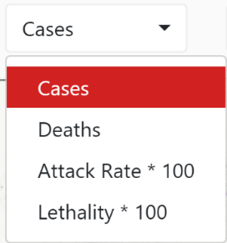**Multiplier**

The Attack Rate and the Lethality have a value called Multiplier (in the example, this value is 100).

* For the attack rate, this informs the Epimap about the population multiplier you have used in the calculation of the Attack Rate. Consult your Epidemiologist to know what was the multiplier (1000; 10000; 100000….. etc).
* For the Lethality, this will inform the Epimap about what multiplier it needs to apply. If you want a single ratio (Death/Cases), simply use the value 1.

The multiplier will appear in the Epimap, in the popups on the map, and in the menus/legends.

* **Thresholds and Color Codes**

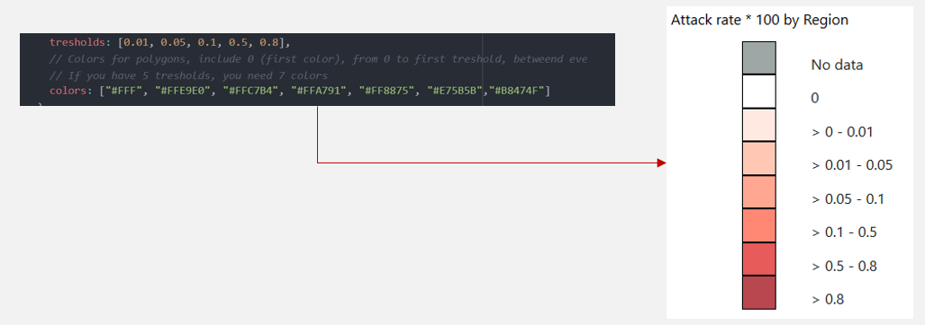

*Note: The final user will still be able to modify Thresholds and Colors in the Epimap using buttons and color pickers, but this will only affect his session (will not be saved when s.he closes the Epimap). By modifying these values, you are defining the standard colors/threshold, used every time a user opens the Epimap.*

**To add another disease:** you simply have to duplicate the entire bloc, including the first and final separators { and }, for example, in the example code given with the initial Epimap, you can observe another disease being added (meningitis).

* **Map configuration**

You can set circles size/color/contour for Cases and Deaths and the color for polygons without data:

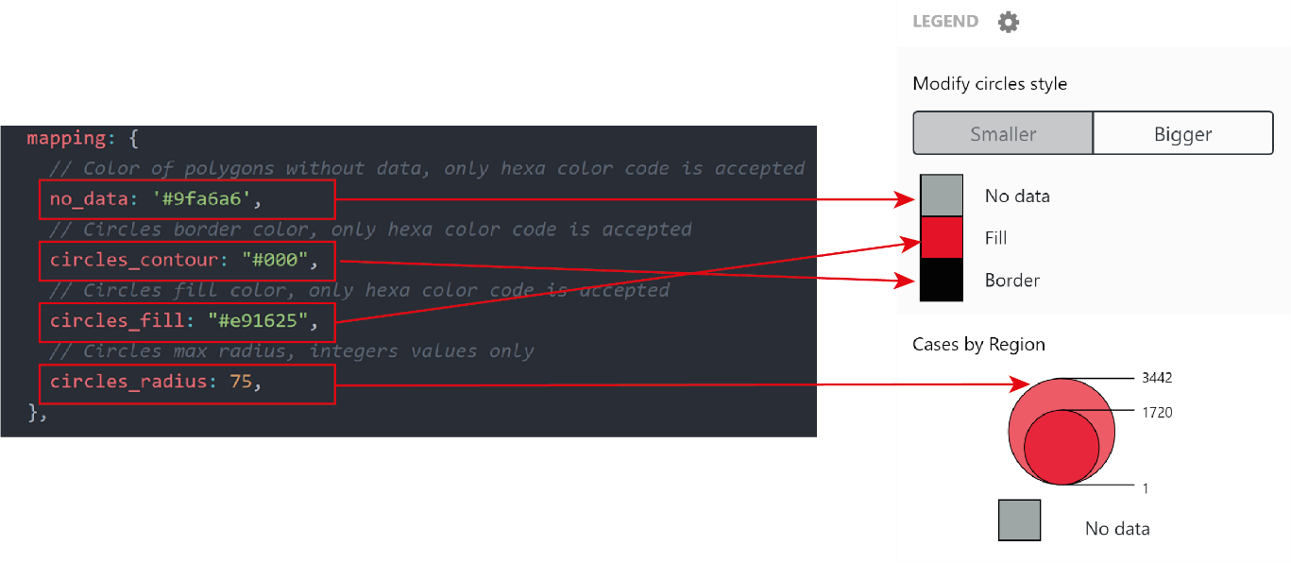

*Note: The final user will still be able to modify Sizes and Colors in the Epimap using buttons and color pickers, but this will only affect his session (will not be saved when s.he closes the Epimap). By modifying these values, you are defining the standard colors/size, used every time a user opens the Epimap.*

* **Epimap initialization:**

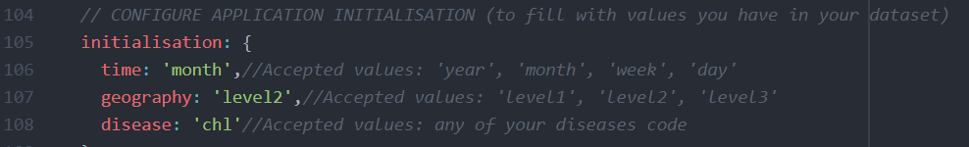

The Epimap initialisation configuration is **mandatory**, it will define the default value for the dropdown menus (geographic level, disease and time unit), the indicator will be set automatically.

* **Information box:**

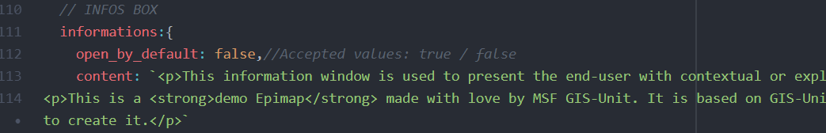

You can set the informations box content and if it will be visible when the application is opened. Set “open_by_default” parameter to true if you want the box to be visible. If setted to false, the box will only appear when user will click on the information button. The text content of the box accepts both simple text and HTML code (if you don’t know how to generate HTML code, you can use [this tool](https://html-online.com/editor/)).

* See how the infobox looks like in the Geoapp: InfoBox

# Advanced Use – Setup and customization of an Epimap

The Epimap v2 is a Standalone Geoapp of the GIS-Unit. Standalone is a technical term used to highlight the fact that it is highly focused on offline use and independent update. Standalone apps are different from online Geoapps available in the MapCentre.

Standalone Apps are divided into 2 components:

* The application itself, composed of the index.html files and the associated JS and CSS files.
* The application container " MSF-GeoApp-Container " in which the files of the application must be placed (see in the doc of the container where to place the files).

Epimap initialization :

1. Download the MSF-GeoApp-Container and unzip the archive on your computer if you don’t already have it
2. Download the Epimap demo folder and place the files in the GeoApp Container
3. Open the MSF-GeoApp-Container.exe file to be sure that the demo application is working
4. Edit your files to customize your Epimap:
   1. Edit the configuration.js file (see 3.3.)
   2. Edit the dataset.csv file (see 3.1.)
   3. Edit each geographical file according to geographic levels you had set in the configuration file (3.2.)

* **GeoApp Container complete documentation :** [**available on Sharepoint**](https://msfintl.sharepoint.com/:f:/s/msfintlcommunities/GIS/Ev9cmzD1IqJBjeW4jjAt83sBJ7BxfDekn5rZwb-HycGyMA?e=peKdpH)

1. And account for cases where one needs to use the Epimap to visualize Attack Rates they receive from external sources, without necessarily having base population figures at hand.